DEPARTMENT OF BOTANY:
EXTENSION LECTURE BY G. SURENDER REDDY GARU, SRBGNR COLLEGE, KHAMMAM.

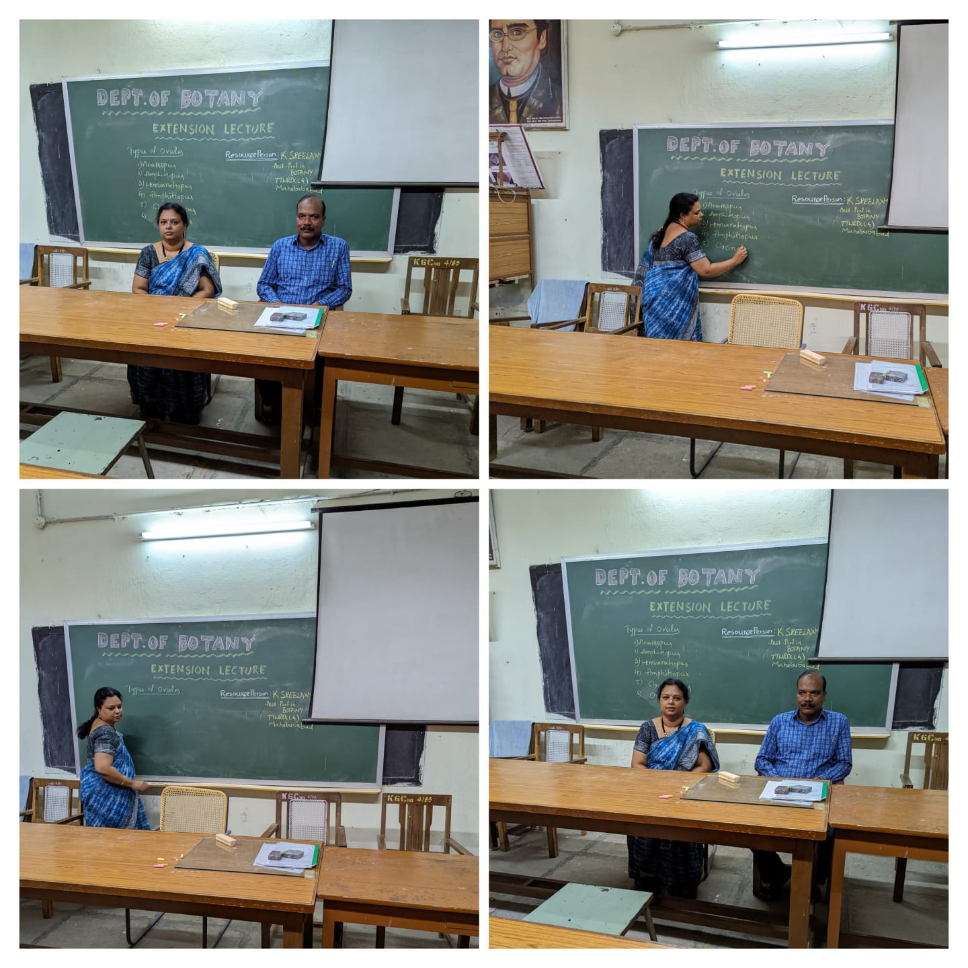

DEPARTMENT OF CHEMISTRY:
EXTENSION LECTURE BY Dr.V.SHANTI KUMAR SIR, ASSISTANT PROFESSOR OF CHEMISTRY SRBGNR COLLEGE KHAMMAM.
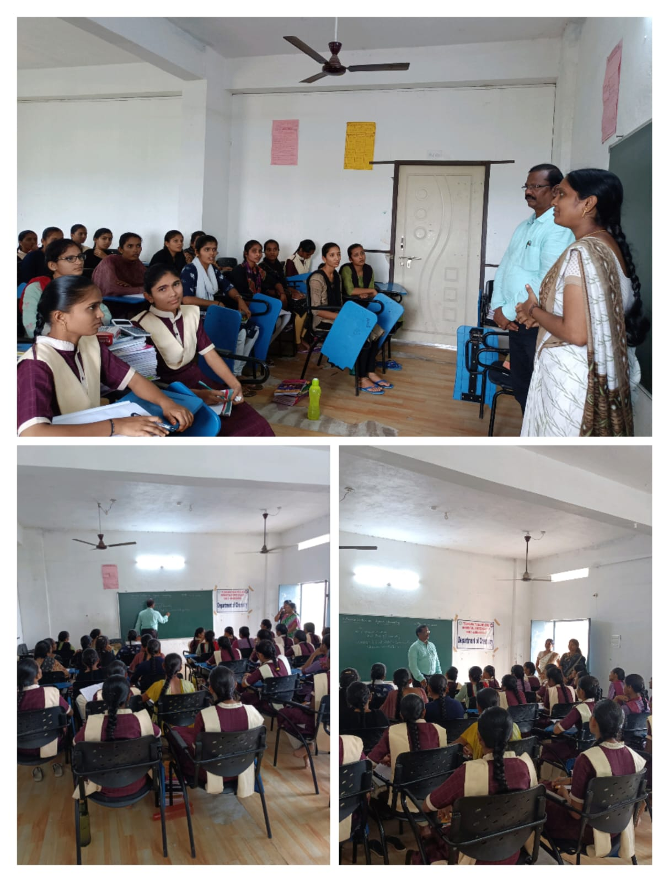

DEPARTMENT OF COMPUTER SCIENCE:
EXTENSION LECTURE BY 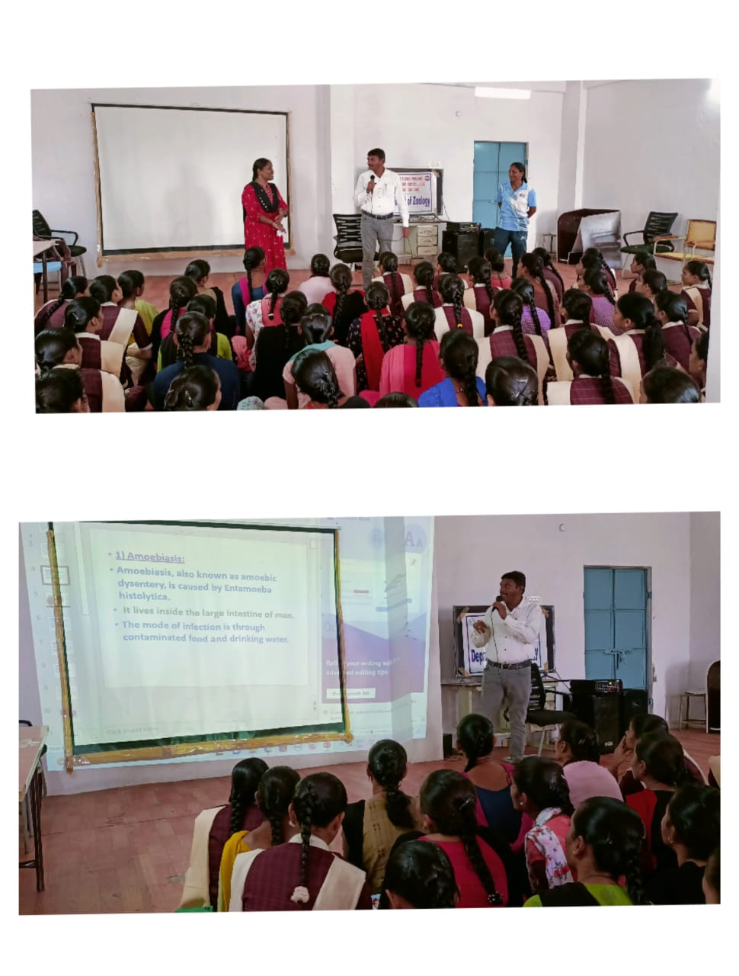
DEPARTMENT OF HISTORY:
EXTENSION LECTURE BY
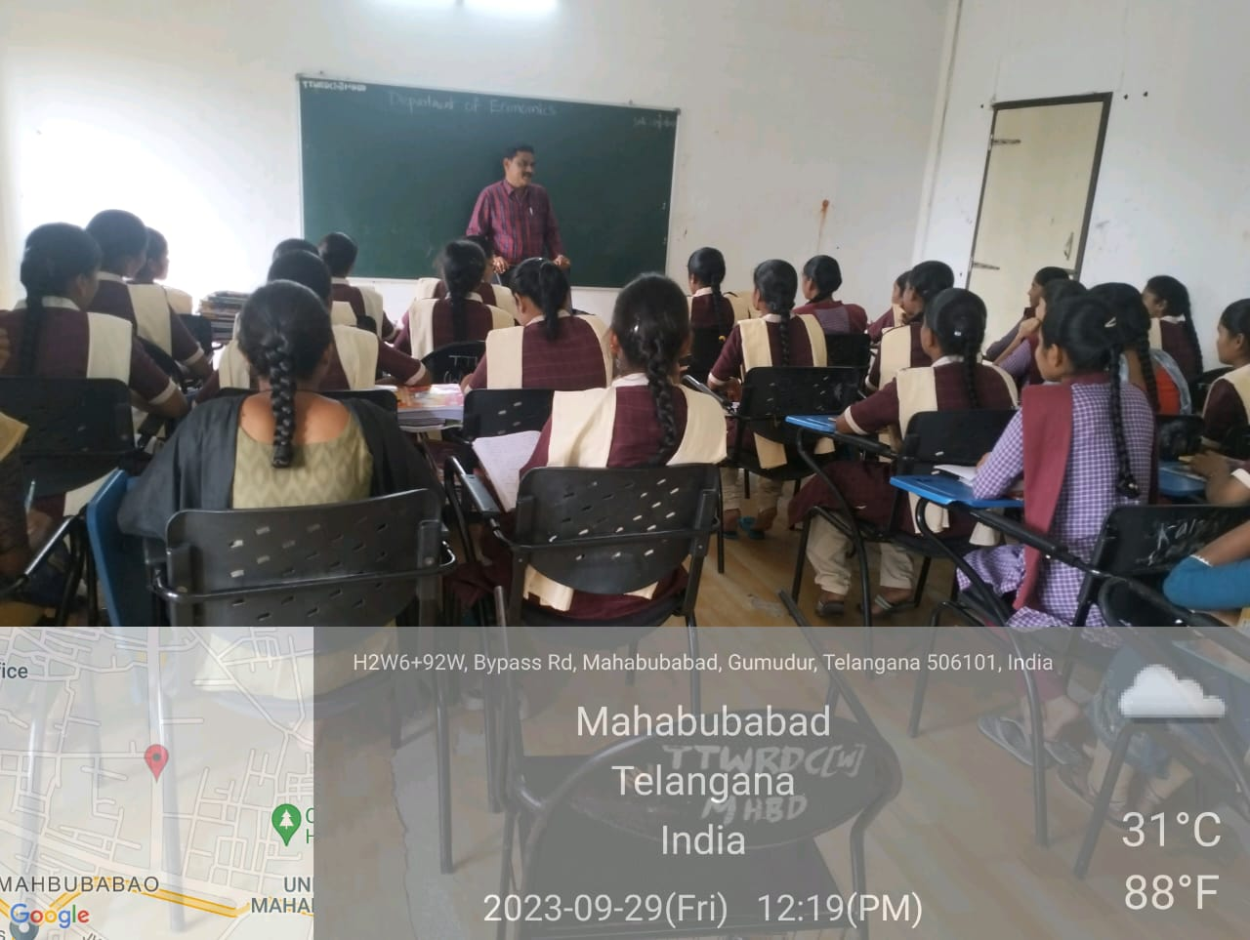

DEPARTMENT OF TELUGU:
EXTENSION LECTURE BY Assistant professor Dr.GADDAM MOHAN RAO (DEPARTMENT OF TELUGU TELANGANA MAHILA UNIVERSITY)

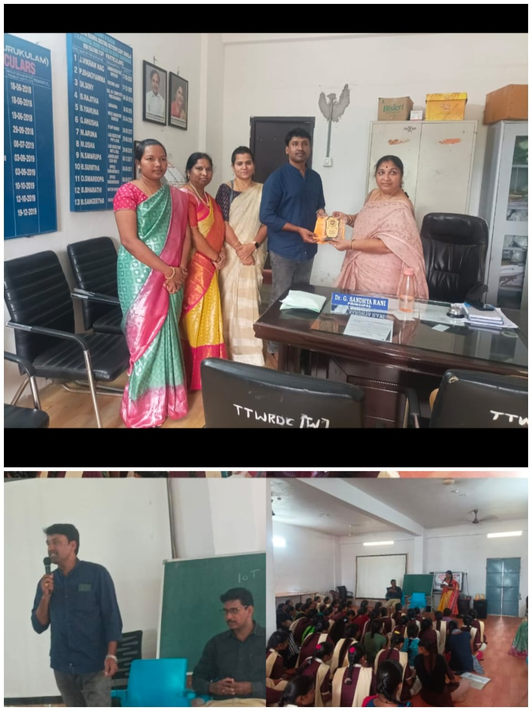

DEPARTMENT OF STATISTICS:
EXTENSION LECTURE BY Dr.S.RAMESH SIR, ASSISTANT PROFESSOR OF COMMERCE SRBGNR COLLEGE KHAMMAM.

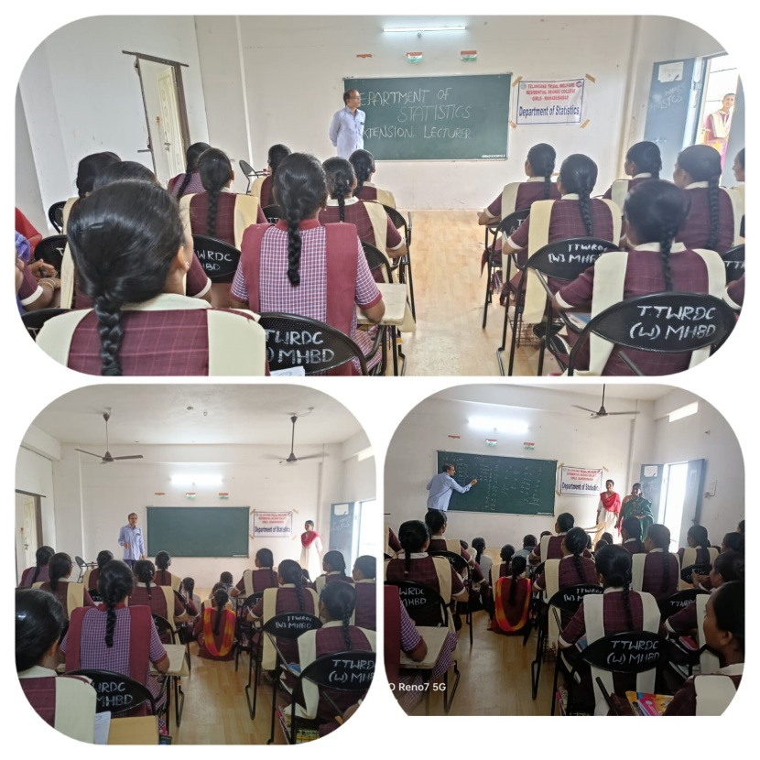

DEPARTMENT OF HISTORY:
EXTENSION LECTURE BY B.VENKATESHWARLU SIR DEVELOPMENT OFFICER.
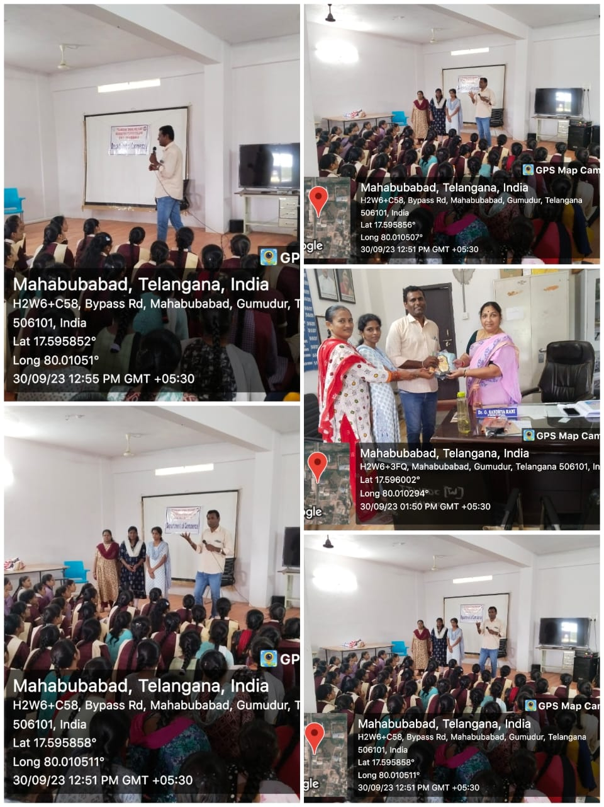
DEPARTMENT OF ENGLISH:
EXTENSION LECTURE BY P.RAM REDDY ASSISTANT PROFESSOR OF ENGLISH, GOVERNMENT DEGREE COLLEGE MAHABUBABAD.
